VISUAL STUDIO

VISUAL BASIC

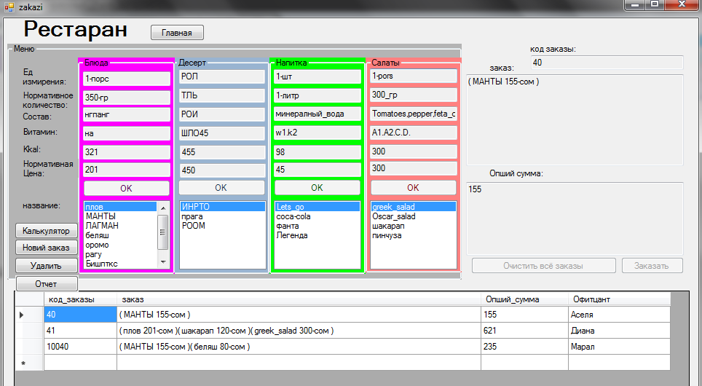

Public Class zakazi

Dim x As Double, y As Double, z As Double, znak As Integer

Private Sub Button3_Click(sender As Object, e As EventArgs) Handles Button3.Click

ЗаказTextBox.Text = ЗаказTextBox.Text + "( " + ListBox3.Text

ЗаказTextBox.Text = ЗаказTextBox.Text + TextBox3.Text + "-сом )"

If TextBox6.Text = "" Then TextBox6.Text = 0

y = TextBox6.Text

x = TextBox3.Text

znak = 1

If znak = 1 Then z = y + x

TextBox6.Text = z

znak = 0

End Sub

Private Sub Button4_Click(sender As Object, e As EventArgs) Handles Button4.Click

ЗаказTextBox.Text = ЗаказTextBox.Text + "( " + ListBox4.Text

ЗаказTextBox.Text = ЗаказTextBox.Text + TextBox4.Text + "-сом )"

If TextBox6.Text = "" Then TextBox6.Text = 0

y = TextBox6.Text

x = TextBox4.Text

znak = 1

If znak = 1 Then z = y + x

TextBox6.Text = z

znak = 0

End Sub

Private Sub CLIENTS_Load(sender As Object, e As EventArgs) Handles MyBase.Load

Me.СалатTableAdapter.Fill(Me.RestourantDataSet.салат)

Me.НапиткаTableAdapter.Fill(Me.RestourantDataSet.напитка)

Me.ДесертTableAdapter.Fill(Me.RestourantDataSet.десерт)

Me.БлюдаTableAdapter.Fill(Me.RestourantDataSet.Блюда)

Me.ЗаказTableAdapter.Fill(Me.RestourantDataSet.заказ)

End Sub

Private Sub Button7_Click(sender As Object, e As EventArgs) Handles Button7.Click

калькулятор.Show()

End Sub

Private Sub Button8_Click_1(sender As Object, e As EventArgs) Handles Button8.Click

main.Show()

Me.Close()

End Sub

Private Sub Button5_Click_1(sender As Object, e As EventArgs) Handles Button5.Click

ЗаказBindingSource.AddNew()

Button1.Enabled = True

Button2.Enabled = True

Button3.Enabled = True

Button4.Enabled = True

Button9.Enabled = True

Button6.Enabled = True

Button5.Enabled = False

End Sub

Private Sub Button6_Click_1(sender As Object, e As EventArgs) Handles Button6.Click

TextBox6.Text = ""

ЗаказTextBox.Text = ""

End Sub

Private Sub Button9_Click_1(sender As Object, e As EventArgs) Handles Button9.Click

Me.Validate()

Me.ЗаказBindingSource.EndEdit()

Me.TableAdapterManager.UpdateAll(Me.RestourantDataSet)

Button1.Enabled = False

Button2.Enabled = False

Button3.Enabled = False

Button4.Enabled = False

Button9.Enabled = False

Button6.Enabled = False

Button5.Enabled = True

End Sub

Private Sub Button10_Click(sender As Object, e As EventArgs) Handles Button10.Click

ЗаказBindingSource.RemoveCurrent()

End Sub

Private Sub Button1_Click_1(sender As Object, e As EventArgs) Handles Button1.Click

ЗаказTextBox.Text = ЗаказTextBox.Text + "( " + ListBox1.Text

ЗаказTextBox.Text = ЗаказTextBox.Text + TEXTBOX1.Text + "-сом )"

If TextBox6.Text = "" Then TextBox6.Text = 0

y = TextBox6.Text

x = TEXTBOX1.Text

znak = 1

If znak = 1 Then z = y + x

TextBox6.Text = z

znak = 0

End Sub

Private Sub Button2_Click_1(sender As Object, e As EventArgs) Handles Button2.Click

ЗаказTextBox.Text = ЗаказTextBox.Text + "( " + ListBox2.Text

ЗаказTextBox.Text = ЗаказTextBox.Text + TextBox2.Text + "-сом )"

If TextBox6.Text = "" Then TextBox6.Text = 0

y = TextBox6.Text

x = TextBox2.Text

znak = 1

If znak = 1 Then z = y + x

TextBox6.Text = z

znak = 0

End Sub

End Class

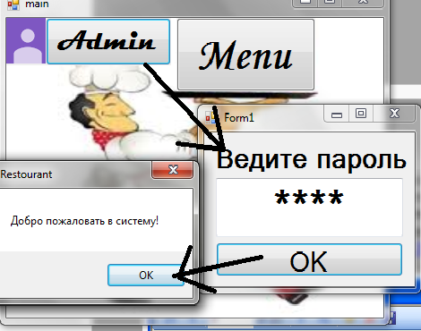

Public Class password

Private Sub Button1_Click(sender As Object, e As EventArgs) Handles Button1.Click

If TextBox1.Text = "1234" Then

MsgBox("Добро пожаловать в систему!")

Me.Close()

admin_main.Show()

Else

MsgBox("Извините, я вас не знаю.")

TextBox1.Text = ""

End If

End Sub

End Class

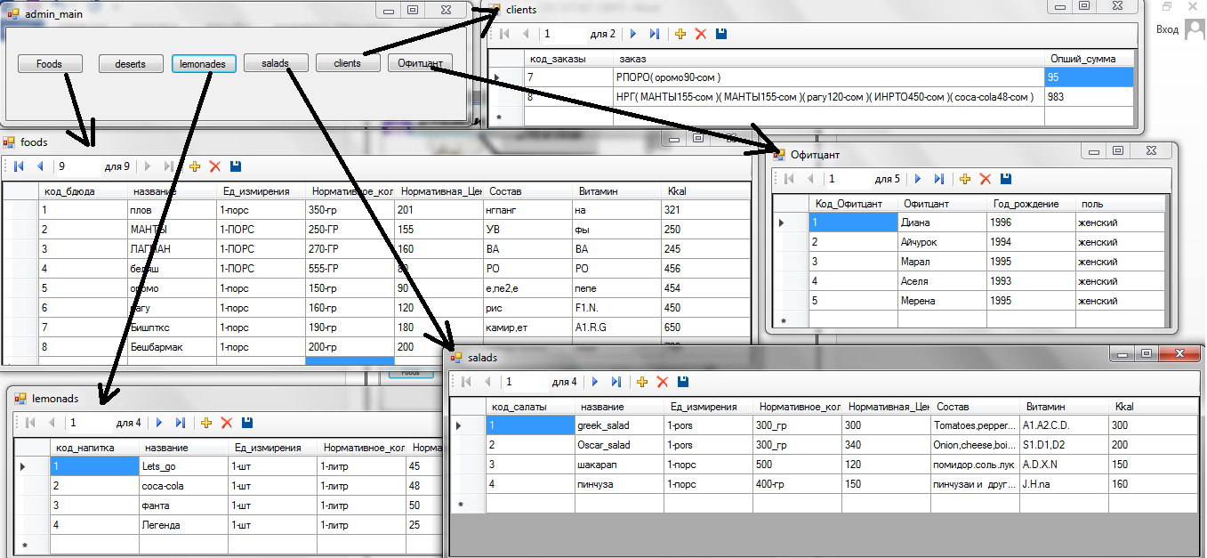

Public Class admin_main

Private Sub Button1_Click(sender As Object, e As EventArgs) Handles Button1.Click

foods.Show()

End Sub

Private Sub Button2_Click(sender As Object, e As EventArgs) Handles Button2.Click

deserts.Show()

End Sub

Private Sub Button3_Click(sender As Object, e As EventArgs) Handles Button3.Click

lemonades.Show()

End Sub

Private Sub Button4_Click(sender As Object, e As EventArgs) Handles Button4.Click

salads.Show()

End Sub

Private Sub Button5_Click(sender As Object, e As EventArgs) Handles Button5.Click

clients.Show()

End Sub

Private Sub Button6_Click(sender As Object, e As EventArgs) Handles Button6.Click

Офитцант.Show()

End Sub

End Class

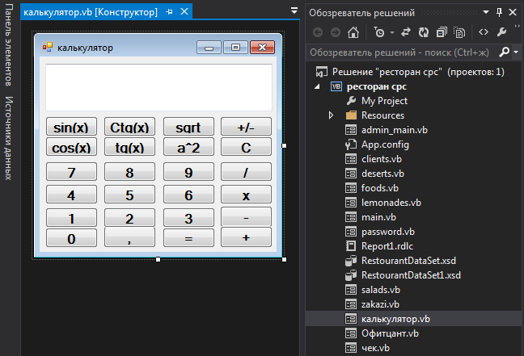

**SQL SERVER**

**RESTOURANT**

